**Initial Vision**

By my signature below, I certify that I have not received improper help nor given it to others in writing this assignment nor have I used any method that would give me an unfair advantage over others in the class. This assignment represents my own work only and I had no assistance from another person or any other source unless it is referenced at the bottom of each appropriate page.

Kishlay Kumar - 21/11/2022

(Full Typed Signature and Date)

**Q1. What person is your hero/heroine? Explain**

While I have not been an ardent follower of anyone in my life and always look to carve out my own unique path rather than walk on the path of another, I have developed a great appreciation for a few individuals who have lived an exemplary life. One of those individuals whose ideas, values, and practices I try to emulate is that of Dr. APJ Abdul Kalam, the former President of India, also known as the ‘Missile Man of India’. From being the son of a boat owner to the becoming the first citizen of India, Dr Kalam displayed many qualities and embodied many virtues that I wish to cultivate and more. Dr Kalam was a visionary, had a passion for learning and his love for the nation and its prosperity and security is something that responsible leaders and citizens of today still look up to. The courage he displayed when he became one of the only three presidents to return a Bill to the Parliament for reconsideration is an example that is still quoted in schools and colleges when explaining the value of a position as powerless (yet symbolic and important) as the President of India.

As a child, Dr. Kalam faced many hurdles in life including his early education, as he had to support his family financially by selling newspapers. He wasn’t the best student in school but always described as a bright student with a passion for learning. His perseverance, and interest in the subjects like mathematics earned him a position in the prestigious DRDO from whence he went on to contribute significantly to India’s aerospace and defence sector. Despite his achievements and high stature, Dr Kalam displayed a remarkable quality of being humble. In the twilight of his life, he often visited colleges and interacted with young students imparting golden lessons on leadership that he had acquired throughout his life. For him, a leader was one who ignited the minds of others and worked maintained the highest standards of integrity. While, I have always tried to value the good qualities in others, it is rare to know someone who embodies all the values that you wish to cultivate in your life. Dr. Kalam was that person who was almost everything that I hope to be and thus my hero for life.

**Q2. What thing do you value most of all? Explain**

There are many things in life that are worth the time and effort you spend on them, but one thing that according to me transcends it all is my family. Throughout the years of my life, I have met many people and made quite a few friends and acquaintances. There are but a few things that have remained constant across all these years and one of those is the unconditional love and support of my family. Whether it is my parents or my brother, they have always been there for me during the good as well as the bad times. They are probably the only ones who would do anything for me without expecting much in return. One of the ideas that I have come to accept and imbibe in my experiences of life is that a life is best lived if lived for others. My hero, Dr Kalam is a prime example of this idea. And I find no better way to live a life than one that is dedicated to the well-being of those that you love.

**Q3. What is your own definition of values?**

For me, values are constructs or ideologies that you believe in, and which define your actions (or behaviour) and its outcomes in a given situation. Our values guide us when dealing with different kinds of situations in our life. They are the motives behind any purposeful action. Values reflect a person's sense of right and wrong or what “needs” to be. For example, since I have always admired people like Dr. Kalam and my father himself works for a government MSME serving the tribals and underserved sections of the society, I strongly believe in the values of equality, dignity, integrity, and justice.

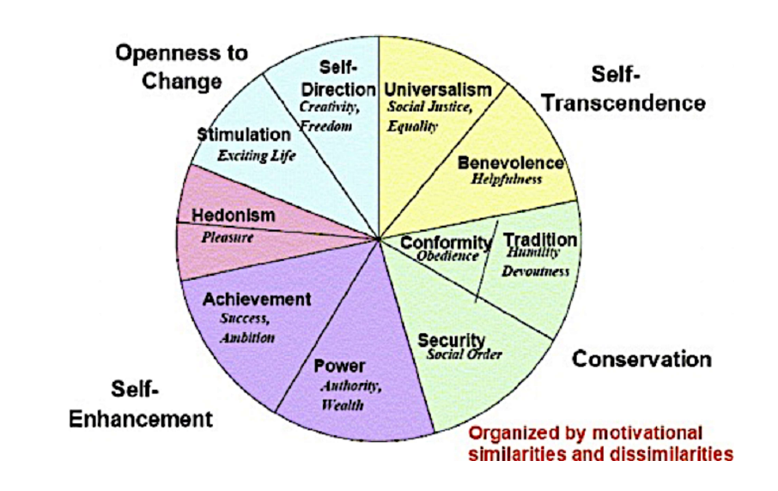

**Q4. What are your core values as found in the Values Sorter?**

|  |  |  |
| --- | --- | --- |
| Equality | Universalism | Self-Transcendence |
| Helping Others | Benevolence | Self-Transcendence |
| Integrity | Universalism | Self-Transcendence |
| Family Security | Security | Conservation |
| Self-reliance | Self-Direction | Openness to change |
| Creativity | Self-Direction | Openness to change |

My core values seem to be clustered around self-transcendence and openness to change. Universal concepts like equality and integrity are ideas that I have inculcated in mind as a child. Self-reliance and creativity are important qualities when working in a team and especially field like Artificial Intelligence which has an expanse as vast as the ocean to explore. However, I seem to lack the motivation to do well for the sake of myself and my personal development. This is something that I feels pulls me down sometimes as I tend to procrastinate in my tasks. The will to improve oneself is a great tool which if leveraged carefully and wisely can be a strong motivator that propels us towards achieving goals and developing other values.

**Q4. How might you use your core values in your work after TLP?**

I hope to be able to use my core values as I move to the industry where I can display exemplary leadership to my peers, juniors, and seniors all alike in terms of what kind of a person I want to be seen as. I would like to be seen as a helpful individual who is easily accessible and approachable and treats each person equally regardless of their achievements or stature. I would like to ensure the security of my family (especially financially) and prove to be the son/brother that they expect me to be. Also, working in the field of AI, I would like to explore solutions for real problems like climate change and agricultural productivity enhancement (both of which have significant impact on India’s economy), through learning and creativity to have a positive impact on the lives of the common people.